Shabbos Stories for
Parshas yisro 5781
Volume 12, Issue 23 24 Shevet/February 6, 2021
Printed L’illuy nishmas Nechama bas R’ Noach, a”hs

For a free subscription, please forward your request to keren18@juno.com
Past stories can be found on the website ShabbosStories.com
The Baal Shem Tov’s
Partner in Olam Haba

One day, it was revealed to the Baal Shem Tov that he had merited that a great Neshamah would be his partner in Olam Haba. The identity of this Neshamah was also revealed to him as being someone who lived in a backwoods village many miles from his home.
Desiring to learn more about his destined partner, the Baal Shem Tov journeyed to this village and asked for the person whose name he had been given. When he met him, the man turned out to be a simple and ignorant Jew, who was hardly literate enough to Daven properly or even to learn a few Pesukim of Chumash.
A few villagers had described this man as an unintelligent individual, and a glutton, as he was quite large. The Baal Shem Tov asked him if he could tell him a little about himself, and the man responded, “I am a simple, uneducated Jew, who earns his living off the land. There is nothing special about me.”

Rented a Room in the Man’s House
The Baal Shem Tov decided to rent a room in the man’s house and observed his behavior for several days. Indeed, as was his reputation, the man seemed to be very ordinary, acting in the way of a simple peasant. Never did the Baal Shem Tov see him learning with an open Sefer, and the only book he saw the man open was a Siddur, which he used very quickly to Daven from every day. It seemed that there wasn’t any exemplary behavior in any area.
The only thing remarkable about this man was his diet. He consumed a vast quantity of food. At a single meal he would eat what the average person would eat in a week, and his girth was witness to his eating habits.
Finally, the Baal Shem Tov asked him directly. “I have reliable information that you are held in great esteem in Shamayim. Perhaps you can tell me why this is so?”
The man just reiterated, “There is nothing special about me. Maybe you should check your sources again.”
The Baal Shem Tov persisted though, and said, “Have you ever, in your life, done a great deed? Perhaps you once saved a life, or gave a great amount to Tzedakah, or made some other great sacrifice for the sake of Hashem?”

“You Have the Wrong Fellow”
The man replied, “I’m sorry to disappoint you, but you have the wrong fellow. I have never done anything of that sort. I’m just a simple farmer. The only extraordinary thing about me is the amount of food I eat. No one eats as much as I do.”
The Baal Shem Tov asked, “Why do you eat so much?”
The man responded, “It is because of my father.” He explained, “My father died Al Kiddush Hashem, and he sanctified Hashem’s Name at the end of his life. Many years ago, at a Pogrom, he was dragged from his bed out into the street, and he was given the choice to convert from Judaism, or he would be put to death. When he refused to convert, they set the barn on fire and threw him into the flames. My father was a very slight, and skinny man, and in just a few moments, he was completely consumed by the fire. There was hardly anything there to burn.
I resolved at that time that if that should ever happen to me, it would never be that way. If it should ever happen that I am ever given the choice to convert from being a Jew or else I must burn for the sake of Hashem’s holy Name, I will never convert, just like my father did, but with me it will be different, and I will burn for a very, very, long time!”

The Baal Shem Tov was astounded at this story. It turned out this simple Yid was eating his every bite L’Sheim Shamayim, solely so he could die Al Kiddush Hashem, if the time ever came to it. The Baal Shem Tov kissed the man on his forehead and said, “I am so fortunate to be able to spend eternity in Olam Haba with such a special individual!”

Reprinted from the Parshas Shemos 5781 email of Torah U’Tefilah as compiled by Rabbi Yehuda Winzelberg.
Story # 1204
Two Admitted But Unalterable Mistakes
From the desk of Yerachmiel Tilles
editor@ascentofsafed.com

Some months after the passing of Rabbi Shneur-Zalman of Liadi, the Alter Rebbe of Chabad, the Jewish community in Haditch received a letter from the Imperial Government. It stated that the cemetery that they were using was located on land that belonged to the Imperial Government, and since they converted it into a cemetery without permission, all the graves there, including the Rebbe’s, must be removed to another location.

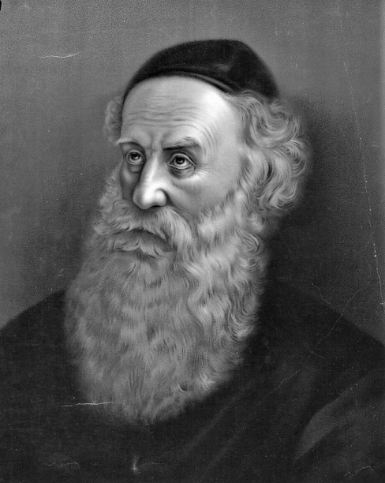
Rabbi Shneur Zalman of Liadi

The Jewish community was shocked and distressed. It was disrespectful to move someone from his eternal rest. They replied that their decision was done with permission of the local authorities.

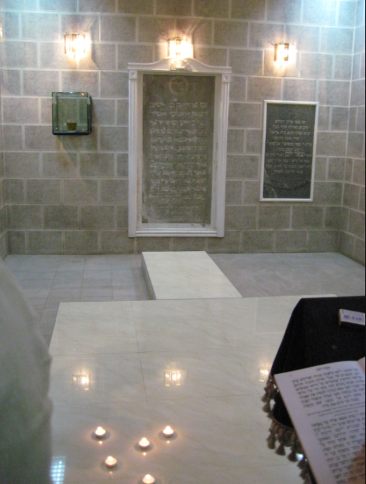
Burial Place of the Alter Rebbe

They sent a copy of the permits from the local jurisdiction where it stated clearly that the provincial government bequeathed that parcel of land to the Jewish community of Haditch for the specific purpose of a burial grounds.

The Imperial Government replied, “Yes, we see that the provincial government gave you permission, but they mistakenly permitted you to use land that is not theirs. Their parcel is a short distance away and you can re-inter your loved ones there. However, they must be removed from the place where they are now buried.”

Offer to Swap Land was Denied
The provincial government acknowledged that it was their mistake and apologized. They offered to swap a larger parcel of land to the Imperial Government in order not to violate the dignity and sanctity of the cemetery.
However, the government was firm: all graves must be removed!
The Alter Rebbe’s son and successor, Rabbi DovBer, known as the Mitteler Rebbe, was informed and was asked what does he prefer to do? Does he want to send someone to move his father, the Alter Rebbe, or should the community do it?

The Mittler Rebbe Sends a
Chassid to Make an Appeal
The Mitteler Rebbe refused to do either. He had heard that one of his father’s former chassidim was an important official in the Imperial office that has the final say on this matter. He sent a chasid to plea with that person to leave the Jewish cemetery and accept the provincial government’s offer of swapping parcels of land.

A Friend of the Imperial Official
The chasid, Rabbi Moshe Vilenker, who was a friend of this official when they were in Liozna together with the Alter Rebbe, was chosen to be the representative. Reb Moshe immediately travelled to the capital, Petersburg, to visit the official.
When the official saw Reb Moshe waiting in the antechamber, he immediately recognized him and granted him an audience. As soon as Reb Moshe entered his office he said, “I’m sure that you came to request something of me. But that is not the ways of chasidim. First you will come to my house this evening, where we will farbreng.
“After the farbrengen (chasidic get-together), you can present your request.”

Agrees to Participate
In the Farbrengen
Having no choice, Reb Moshe agreed to this arrangement. They sat down, sang the Alter Rebbe’s nigunim (songs and melodies), and reminisced about their time with the Rebbe.
The officer then said, “You of course noticed that I have a beautiful mansion; I am wealthy and have whatever I desire. But you should know the truth is that I don’t really enjoy it, not even for a moment.
Yes, it sounds strange, but let me tell you why. Even when I was a student by the Rebbe, I had my doubts about G-d, and that is what ultimately caused me to leave and eventually become what I became. However, one time before I left, without explaining his reasons, the Rebbe instructed me to go visit the tzaddik, Rabbi Aharon of Karlin.
“R. Aharon’s custom was that he didn’t accept people in yechidus (private audience), as our Rebbe did. Whoever came to him would sit in the beis hamidrash (“study hall”), say Tehillim (Psalms) or learn and wait until the tzadik gave him an answer.

“Maybe, After All, There is a G-d’
“After I was sitting for some time, the tzadik entered the crowded beis hamidrash from his room that was adjoining it, and, without directing his gaze towards any particular person, said, “Young man, young man! Maybe, after all, there is a G-d.”
“When he said this, no one in the room took it as if his question had been answered, and everyone remained in their place. A few minutes later, he came into the room for a second time and repeated the exact same words.
“When the same scene repeated itself a third time, I realized he was talking to me! He was informing me that notwithstanding my questions and doubts, I cannot dismiss the possibility that there is a Creator.

Can’t Enjoy Eating
Forbidden Foods
So now, every time I sit down to enjoy something that is forbidden by the Torah, those words come back and haunt me. But I am too weak and don’t have the strength and will power to give up everything I have.”
“Some hours later, he said, ‘Now that we farbrenged, please tell me what is the reason of your coming to visit me?’
When Reb Moshe informed him of the dilemma and showed him the legal papers, he immediately replied, “I will agree to accept the offer of the provincial government, but only for the Rebbe’s sake.’”

Why the Alter Rebbe Wanted
To be Buried in Haditch
In the book, “B’Ohel Chabad,” published in 1920 by a grandson of a chasid of the third Rebbe, the Tzemach Tzedek, grandson of the Alter Rebbe, he notes that his grandfather told him, “Chasidim say that is why the Alter Rebbe expressed some days before his passing a desire to be interred in Haditch. He wanted to help all the Jews buried there that their eternal rest not be disturbed. And that was accomplished only because he too was there. So he did a favor for other Jews even after his departure from this physical world.”

Source: Adapted bys Yerachmiel Tilles from the writings of Rabbi Sholom DovBer Avtzon, as published in “Living Jewis # 721 (Shmos 5780). Rabbi Avtzon is a veteran educator and the author of numerous books on the Rebbes of Chabad and their chasidim. He is available to farbreng and can be contacted at avtzonbooks@ gmail.com
Biographical note: Rabbi Shneur Zalman [of blessed memory: 18 Elul 5505 - 24 Tevet 5573 (1745 - Dec. 1812 C.E.)], was one of the main disciples of the Maggid of Mezritch, successor to the Baal Shem Tov. He is the founder of the Chabad-Chassidic movement and the author of Shulchan Aruch HaRav and Tanya as well as many other major works in both Jewish law and the mystical teachings.

Reprinted from the Parshat Shemos 5781 email of KabbalaOnline.org, a project of Ascent of Safed.

The Non-Jewish
Post Office Clerk
By Rabbi Shmuel Choueka

A story is told about a yeshivah student in Europe pre-World War II, who went the post office to buy some stamps. When the clerk completed the transaction, he accidentally gave the student too much change.
The student went to ask his Rabbi, Rav Yaakov Kamenetzky, what he should do, and the Rabbi told him that he must go back and return the money. He did so the next day, and the clerk was amazed.
For the next few weeks, whenever a yeshivah student came to make a purchase, he deliberately gave them extra change to see what they would do. The Rabbi heard about it and warned the students that they should always return the extra money. The clerk was extremely impressed by the integrity of these Jews, and when the war broke out, he risked his life to save many Jews from being captured by the Nazis.
In our daily routines, we all interact with others and have opportunities to bring honor to the Jewish nation. It could be by saying good morning to the neighbor who is walking his dog, holding the door for someone who is walking into a store right behind us, or smiling to the cashier and not speaking on the phone.
We have the ability to bring honor to our nation and to Hashem in the eyes of the world. Let’s keep in mind that our actions are often being scrutinized by the people around us whether we like it or not. Let’s try our best to always do the right thing, and thereby bring honor and glory to our nation and to Hashem.

Reprinted from the Parashat Shemot 5781 email of the Jersey Shore Torah Bulletin as reprinted in Shabbat Shalom from Cyberspace as compiled by Rabbi David Bibi.
The Unexpected $1,000

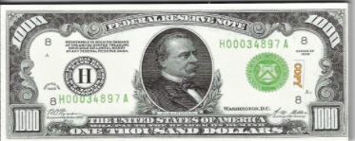

About 40 years ago, a man from our community owned a closeout store on Broadway. A man came in early one morning and made an order for $1,000 worth of handbags. He said to the owner, “I’m leaving you cash to pay for the order, hold the bags, and I’ll come back later today to pick them up.”
10 minutes later, Rabbi Benoliel went to the store to collect tzedaka for Mikdash Melech. The owner of the store asked how much the rabbi needed, and Rabbi Benoliel said, “$1,000 will help us pay the mortgage.” The man said, “Rabbi, I don’t usually have cash, but I happen to have $1,000 cash from an earlier sale. Please take it for the yeshivah.”
Then something amazing happened. The owner of the store waited and waited, but the man who bought the handbags never came back. He didn’t leave any information and didn’t contact the store owner again. The man who owned the store gave his money from a sale directly to support a kollel, and Hashem paid him back immediately!

Reprinted from the Parshat Vayishlach 5781 email of Rabbi Amram Sananes as written by Jack E. Rahmey.

Letters Between a
Chasid and His Rebbe

ONE OF THE GERER REBBES had a talmid who needed to go out for business. This meant moving his family to the big city where it could be detrimental to their ruchnius (spiritual health).
The chassid turned to his Rebbe for guidance. The Rebbe listened to his story, yet encouraged him to make the move with one condition; he must write him a letter every so often and update him on how things where doing.
Following his Rebbe’s guidance, the chasid travelled with his family to the big city. In his first letter, the chasid wrote to the Rebbe how the ruchnius situation was terrible and it disgusted and bothered him tremendously, etc. he even asked the Rebbe if he should return. The Rebbe sent back that it was okay for him to stay. The next few letters basically held the same content. A little while passed, and this time the chassid sent a letter to the Rebbe saying, “'Baruch Hashem,the Rebbe doesn’t have to worry, I really don’t know why I was so bothered by the situation here, it is really not as bad as I thought…”
This time, the Rebbe sent back a letter to the chasid stating that he should pack his bags and move back to the shtetel with his family immediately…

Reprinted from the Parshas Shemos 5781of email of Eitz HaChayim.

Who Doles Out Life to All the Living:
A Small Miracle in the Candy Store
By S.K.

I spent a long time looking for work until I found a job. This job was tailored for me, at a candy store in my neighborhood. True, I do not have a job every day, but Baruch Hashem I work most of the week which is enough to sustain me.
There is an Arab there by the name of Achmed, who does not like me so much that I am in the store as he feels threatened by me and that there is a competition as to who is more experienced.
Due to his secretive competition, he tries to get the attention of the boss to show he is more experienced which is fine by me. What bothers me are the challenges he presents when he talks bad about me to the boss and he cannot prove
anything as it is all a lie and a ruse, and I cannot defend myself because he does this behind my back and I am not aware.

Asking the Creator for His Help
When I saw that the boss was tending to believe him (especially since he has been there many years), I asked the Creator to step in to help me. The next day we had a large event that we had prepared for to meet the high expectations and standards of the customer.

That day, Achmed raised a knife to cut a petit four, and he accidentally cut his palm with the sharp knife, a very deep cut. He quickly ran to the clinic for treatment, and I was left alone to prepare and arrange the large order.

The Story is Not Over
The story is not over. After a week of not coming to work because of the cut and the stitches, he called the boss to tell him he was not feeling well, and I worked extra hours in a pleasant environment.
Two days later we found out he had corona which gave me another ten days of quiet and the boss was able to see how I worked and not how the other worker was bad-mouthing me without my knowing.

Rewarded with a Raise
And More Responsibility
Now that the boss saw that he had a reliable, dedicated worker, he gave me more responsibility and a raise. He also gave me more hours which made it easier for me to support my family. It is important to point out that this other worker had never cut himself all the years he was working, he never took vacation so as not to lose his seniority.
But a short Tefillah from the depth of the heart caused the Creator to arrange the cut and corona and enough time for the boss to see what was really happening. With thanks to the Creator of the World for all His kindnesses.

Reprinted from the Parshas Shemos 5781 email of Tiv Hakehila.

Wishing One’s Problems
Onto Another Yid?

A story is told about R’ Chaim Volozhiner (Itzkowitz) zt”l, the preeminent disciple of the Gaon of Vilna zt”l and the founder of the renowned Yeshivah in Volozhin, Lithuania. The “Volozhiner Yeshiva” began in 1803 and soon became renowned as the “Mother of all Yeshivos” after which many other such yeshivos were modeled.

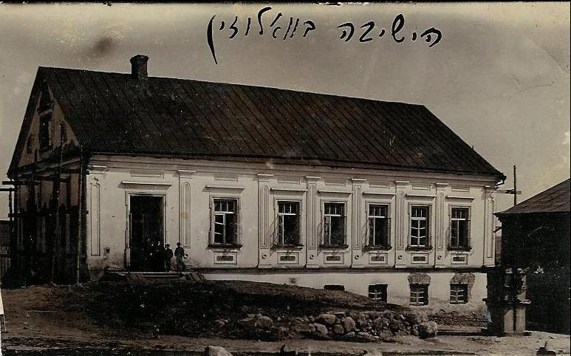
Old photo of the Volozhin yeshiva

The town of Volozhin was built on the main road leading from Vilna to Minsk. It is apportioned into two sections: the “lower neighborhood” along the river and the “upper neighborhood” toward the hills. It is divided by a river, with a bridge connecting the two parts of the city.

Two Ravs for the Town
In the 1800’s, each section maintained their own Rav, however, for the most part, the Jewish population of Volozhin was considered one community. R’ Chaim served on one side of the river, while a certain R’ Elya served on the other. Since the two communities were not really distinct, there was an uncomfortable overlap in the activities of the two Rabbanim.
People would sometimes gripe and say that one city cannot have “two kings wearing one crown” (Chullin 60b). R’ Chaim never expressed any bitterness about this situation, in keeping with the advice he once wrote in a letter: “One should never bear any resentment towards another, even inwardly, and certainly one should never express resentment to others. Patience and tolerance will help a person achieve his desires far more than all the resentment in the world.”

Showing Great Respect for R’ Elya
This was his way and he showed great respect to R’ Elya at every opportunity. However, a number of years after R’ Chaim founded the Volozhin Yeshivah, a vacancy opened up in the rabbinate of a nearby city. R’ Chaim sent a message that it would be best if R’ Elya were to leave Volozhin to take the other position.
When R’ Elya’s wife heard this message, she was incensed “What nerve telling my husband to leave his post!” she exclaimed. She insisted that R’ Elya respond that R’ Chaim should take the new post but R’ Elya quickly reproached her and told her that the wish of the great R’ Chaim Volozhiner must be obeyed. Without another word of discussion, he summoned a wagon, loaded his meager possessions on it - what did he own already? A Shas, a Shulchan Aruch, perhaps a few other seforim and a few pots and pans - and set off for the nearby town, where he took the rabbinical post.

Wishing Such Troubles for R’ Elya
Not long after R’ Elya and his wife left Volozhin, R’ Chaim’s 1-year-old grandson, the son of R’ Itzele zt”l, took ill and passed away. While trying to console his son, R’ Chaim remarked, “If only R’ Elya could have troubles like yours,” a reference to the fact that R’ Elya had no children.
He explained to his grieving family that indeed, their situation was preferable in light of the well-known Medrash in Parshas Shemos (Shemos Rabbah 1:17) which relates that when Amram separated from his wife Yocheved, their daughter Miriam told him, “Your decree is worse than Pharaoh’s, for Pharaoh decreed that the male newborn die only in this world, while you (by separating and not having children at all) have decreed death for them both in this world and in the World to Come.”
R’ Elya never had a child so his troubles were infinitely worse. This remark was subsequently reported to R’ Elya. Miraculously, a short time later, R’ Elya and his wife were finally blessed with a son. The parents’ joy was unbounded, and their hearts were full of love for the precious gift Hashem had sent them.

The Baby Contracted Typhus
When the baby reached the same age at which R’ Itzele’s son had passed away, he contracted typhus, a disease for which there was no cure at that time. Typically, a patient’s condition would grow progressively worse until he reached a crisis point. Usually there was one critical night, and if the patient survived it, he would gradually recover. If not ....
The doctor had warned R’ Elya and his wife to expect this crisis from the beginning of the baby’s illness, and they lived in constant fear of it. When the decisive night finally arrived, R’ Elya sat by the child’s bed reciting Tehillim and praying with all his heart.
From time to time, he punctuated his Tehillim with a heartfelt cry, “This isn’t what R’ Chaim meant! This isn’t what R’ Chaim meant!” Hashem heard his tefillos and the young child overcame the crisis and returned to good health. According to one version of the story, that child grew up to become the father of the Rashash, R’ Shmuel Strashun zt”l.

Reprinted from the Parshas Shemos 5781 email of Torah Tavlin.

The Fear of the Judge
By Rabbi Dovid Goldwasser

R’ Mendel of Riminov and the Ohev Yisroel once came to visit the Chozeh of Lublin in Lanzut, Poland, for Shabbos. Thousands of people living in the surrounding areas came to spend Shabbos with these distinguished tzaddikim.
The maskilim (adherents of the Jewish Enlightenment movement who had cast off the yoke of Torah and mitzvos) were very upset by this development, so one of them went to a government official and claimed the leaders were misleading the community and feeding them lies.
As the three tzaddikim sat together at one of the meals, a troop of officers arrived to arrest them. All those present were overcome with fear and couldn’t imagine why they had been targeted. Although they tried to dissuade the officers from making the arrest, they were unsuccessful, and no appeal could be made the following day as it was a national holiday.
Two days later, the three rabbis were brought before a judge. R’ Mendel of Riminov was chosen to be the rabbis’ spokesman, as he was the most fluent of the three in the Polish language.
“We faithfully serve the Holy One blessed be He with purity of thought,” he explained to the judge. “We came here to learn from our elder, the great Chozeh of Lublin, who is the most erudite and well-informed of us concerning this service of G-d.”
“Why are you dressed in white?” demanded the judge.

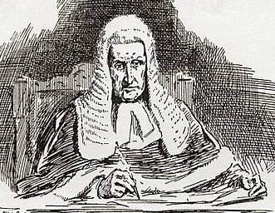

“And why is our master, the judge, wearing black?” retorted R’ Mendel.
This response greatly angered the judge, and he shouted, “Do you know before whom you’re standing?”
“Indeed,” answered R’ Mendel, “we are very aware before whom we stand. And if the judge continues to speak to us in such a harsh manner, we won’t answer.”
With that, R’ Mendel removed the shtreimel he was wearing, and his shining countenance was revealed in full. It was so awe-inspiring that the judge was taken aback. He recognized that the three individuals before him were of unusual stature and was overcome with apprehension and trembling. With great difficulty, he said, “You are free. Go home all three of you. I want nothing to do with people like you ever again.”

Excerpted from the January 8, 2021 email of The Jewish Press, from the article “Do You Really Fear G-d?”

